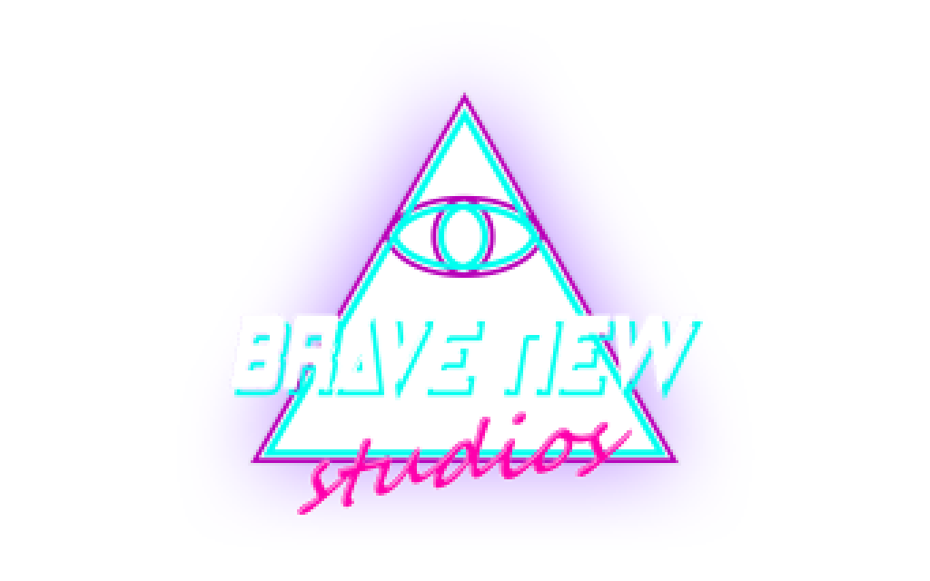
Number One With A Bullet

Version History

v1.0 – That’s all folks!

Game Description

Imagine if when Michael Jackson filmed his hit music video Thriller, what he saw through his eyes was merely an illusion of virtual reality. What if the expertly timed choreography was actually the choreography of a warzone in reality. Instead of jiving with zombies, Michael’s physical body was, unbeknownst to him, slaying actual zombies in a dystopian wasteland of the future. In his mind he’s dropping hits on Billboard like it’s 1982, but in reality he’s dropping hits on the infestation in 2082.

Number One With A Bullet is the rhythm game for the chemically imbalanced. Where most rhythm games will have you tap buttons to the smooth rhythms of Afternoon Delight, we here at Brave New Studios don’t take kindly to such pacifism. If you want to build that combo meter, it’s going to have to be on the decapitated corpses of the infested scum.

Mechanics

As enemies enter your screen, they will protect themselves with force shields. When the timing is right, they will lower their guard to make their attack. This is your window to strike. Miss or attack too early while their shields are still up, and you will take damage. A shrinking reticle will indicate when to time your attacks.

Chaining consecutive attacks will repair your health and build your combo meter. Each kill is worth a base 10 points but for every 10 hits of a combo, your score multiplier will increase by 1.

Controls

Tap and drag player character to move

Tap enemies to shoot from distance or melee when close range

Flick from player to enemy to dash attack

Screenshots

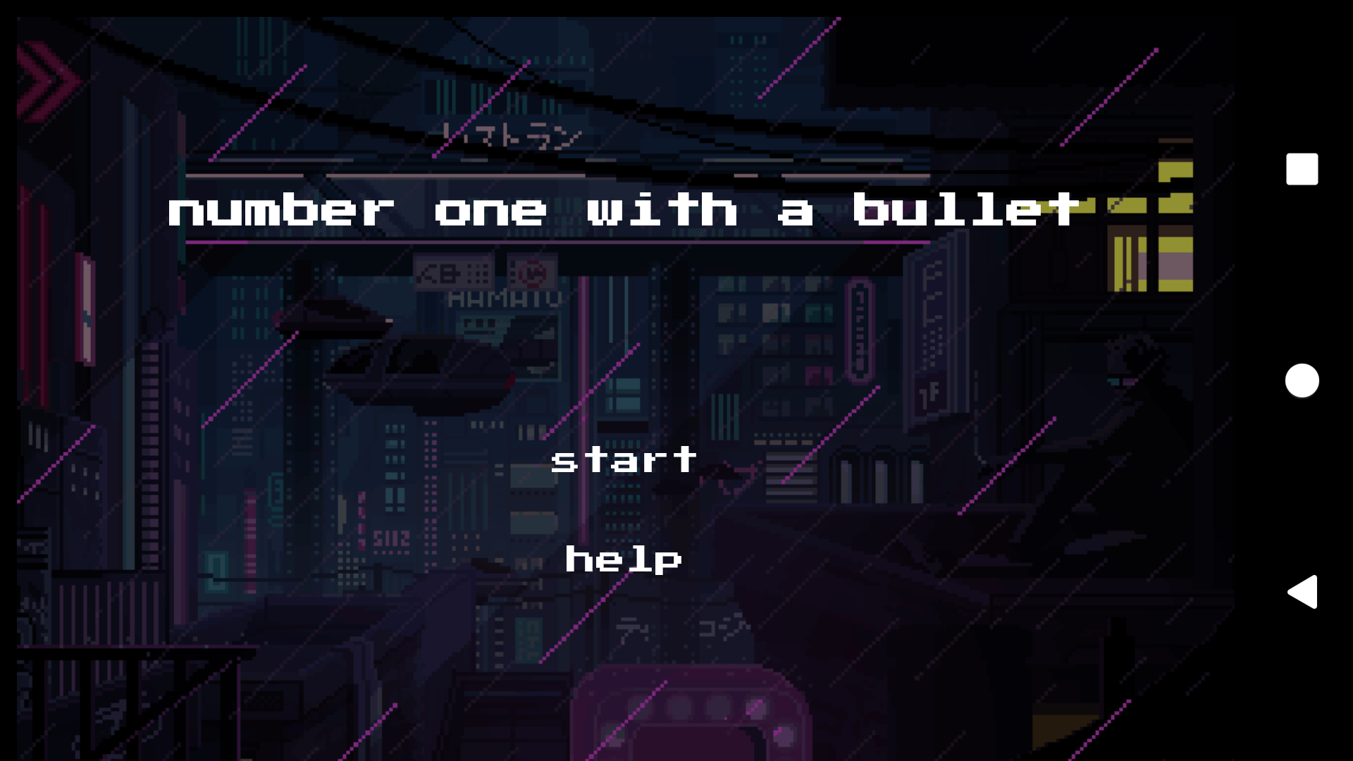
Fig 1. Start screen

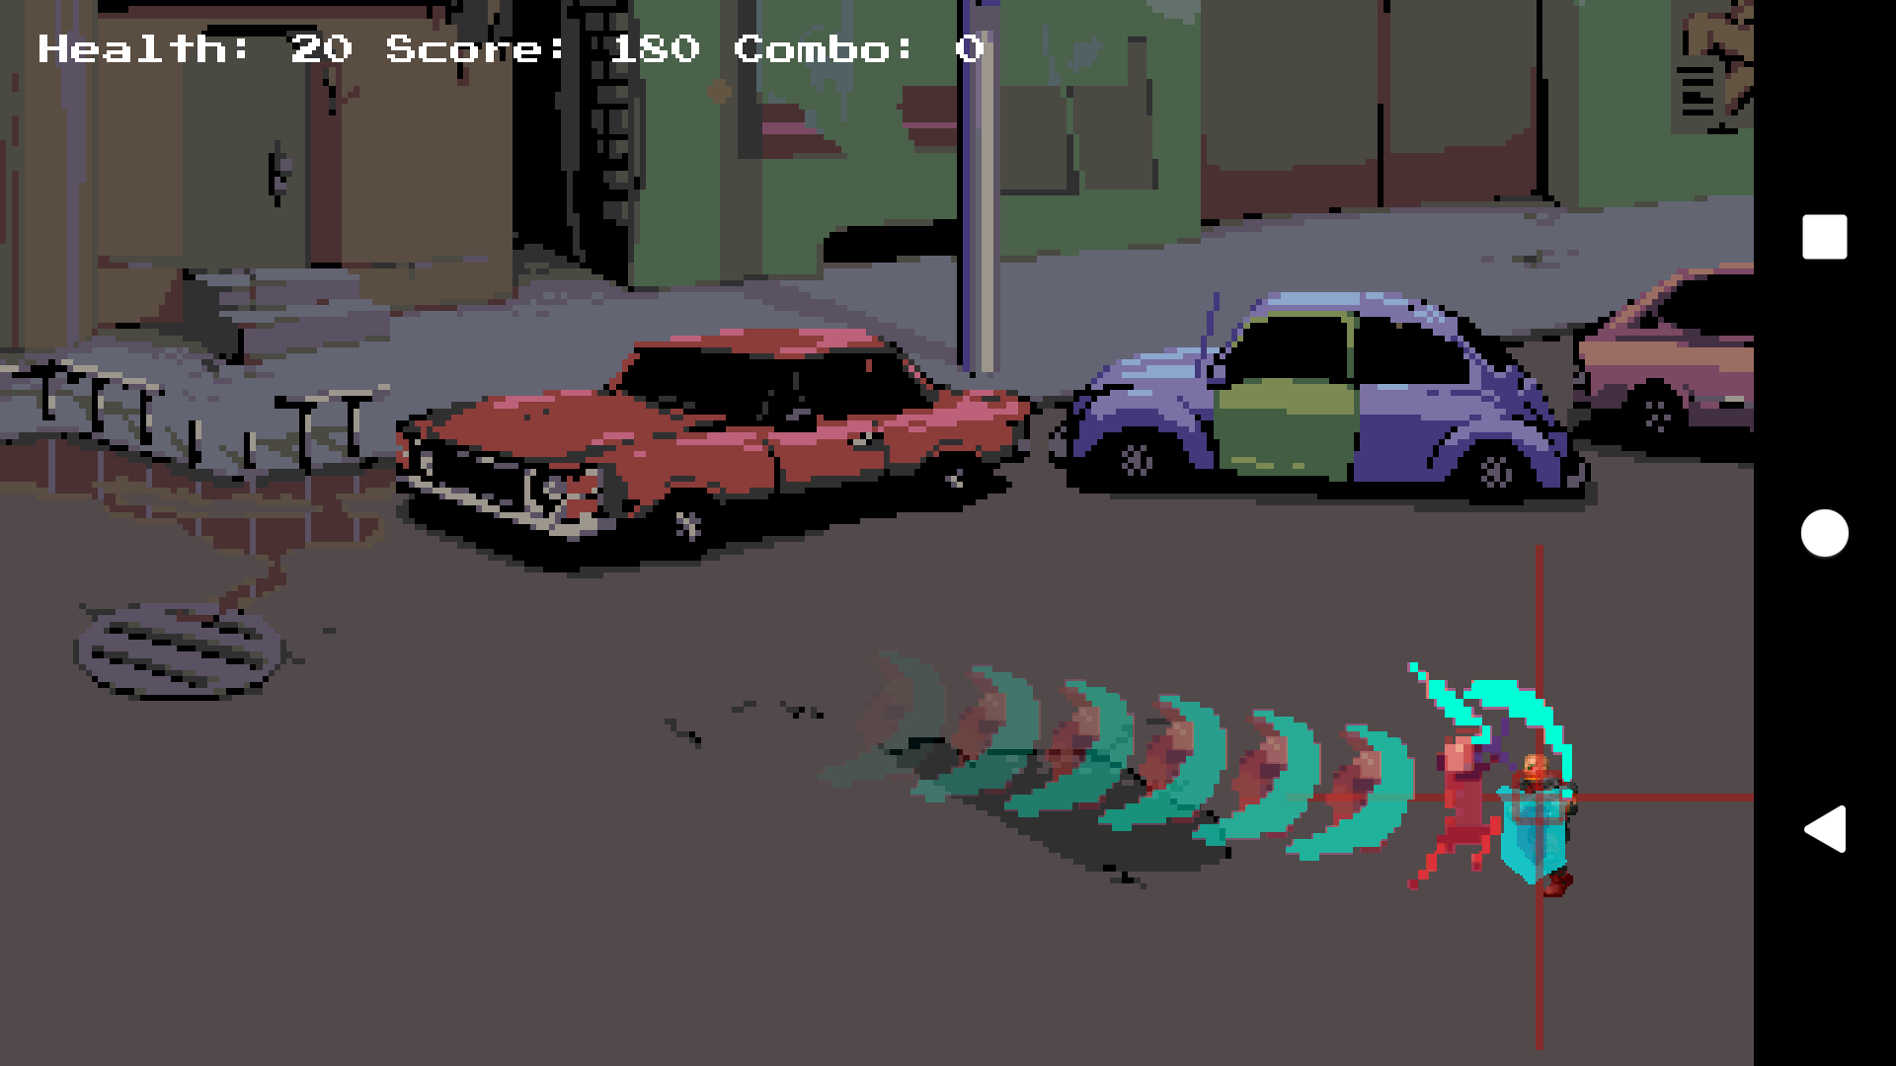
Fig 2. Dash attack

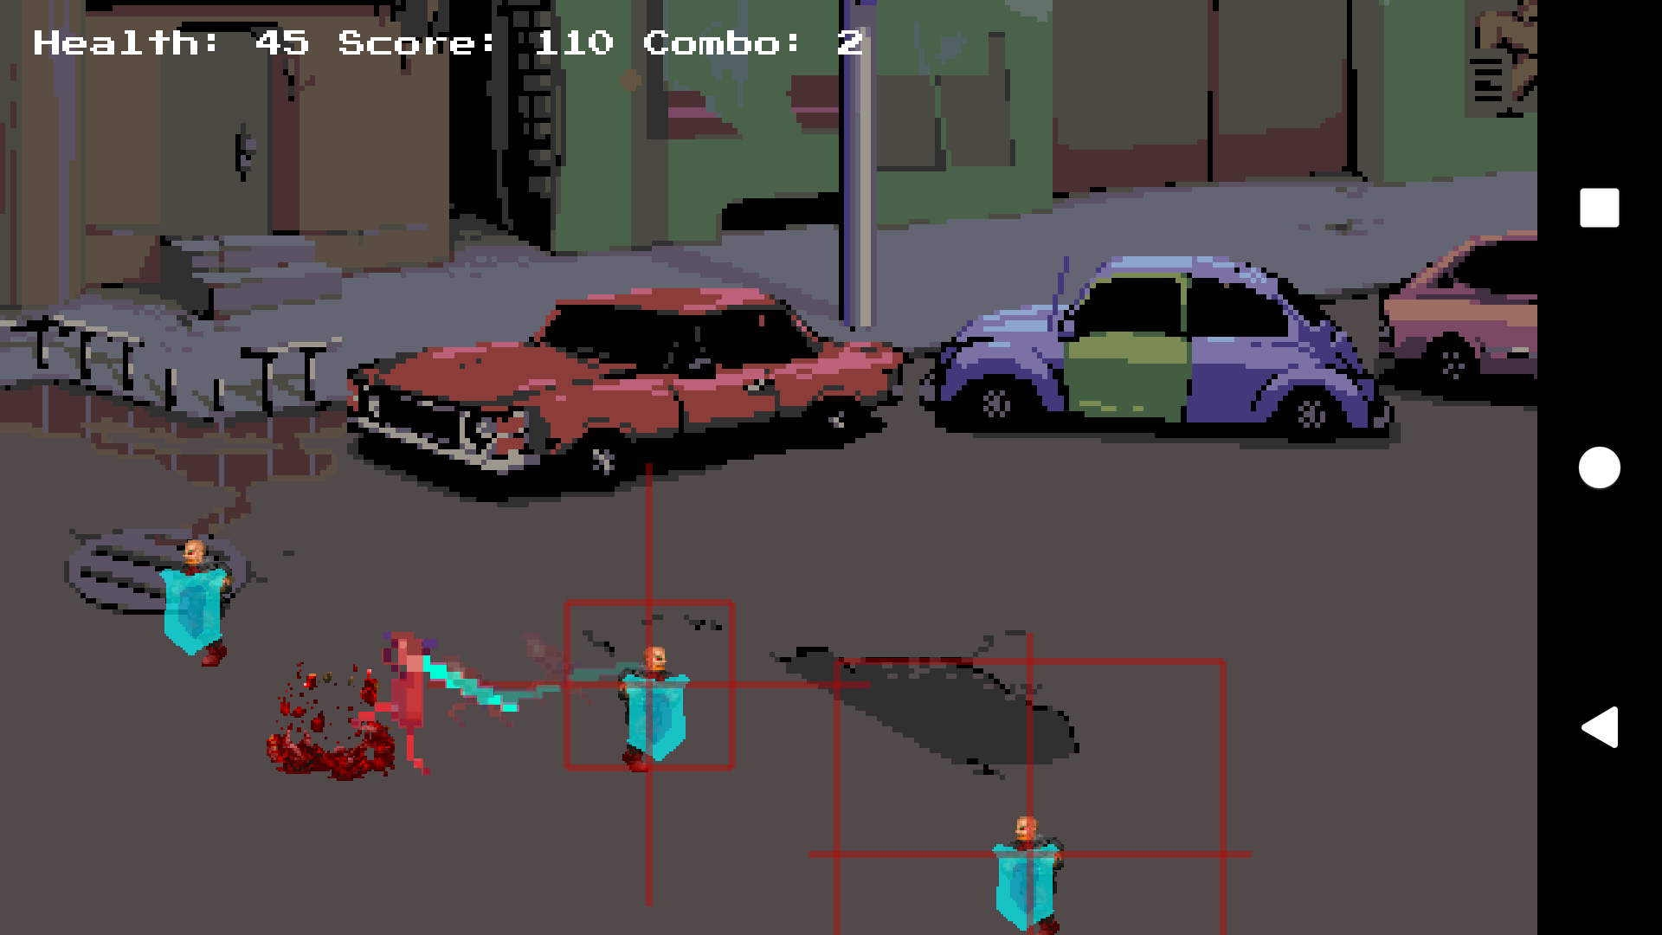
Fig 3. Gibbed!

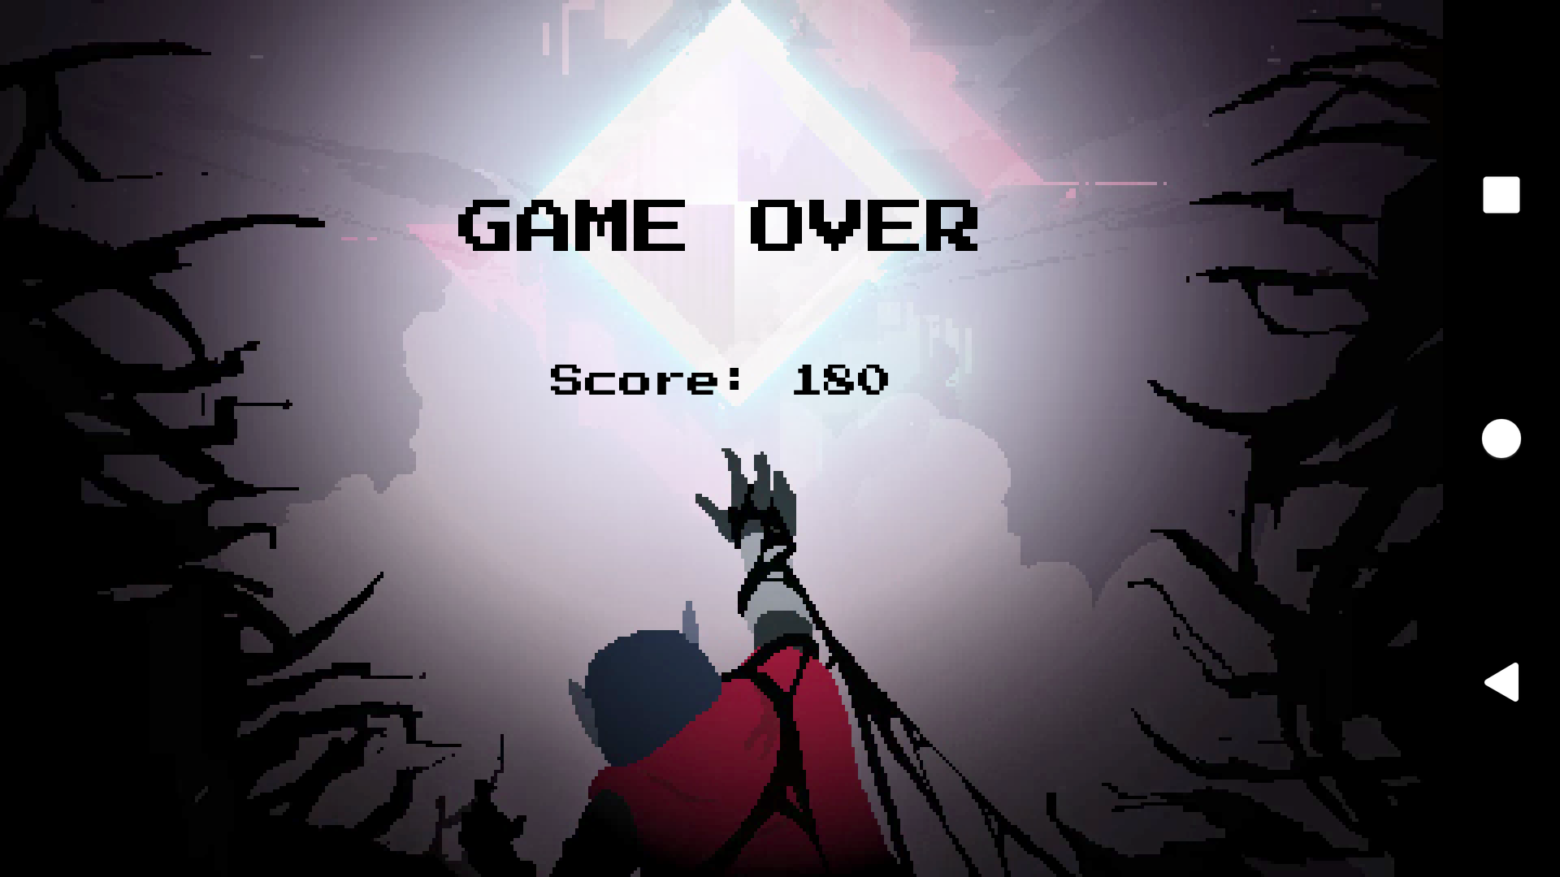
Fig 4. Game over screen

